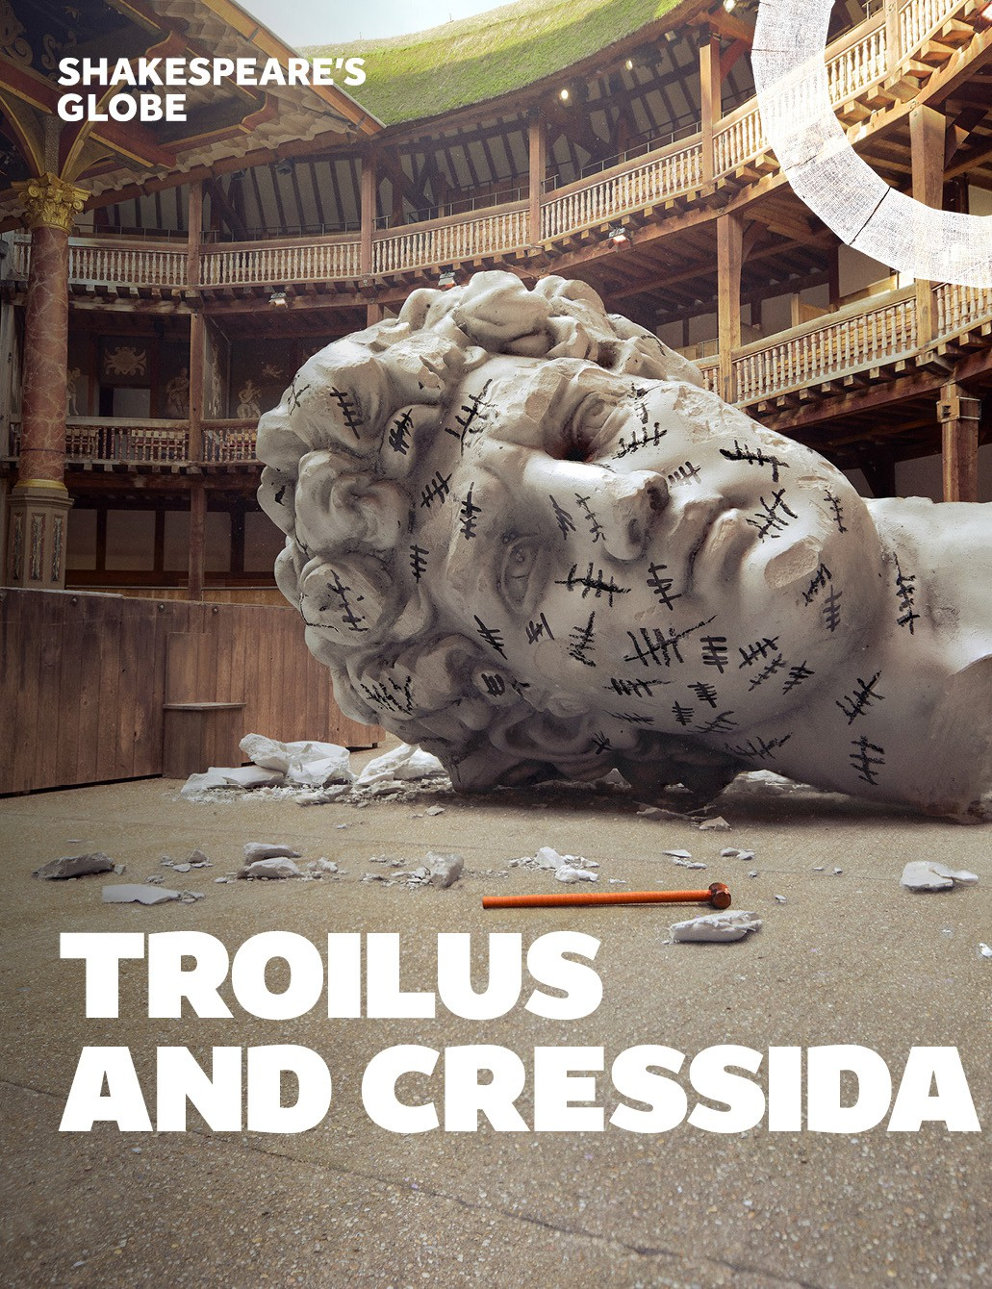
A Visual Story
To support your visit to Shakespeare’s Globe.

Contents


Visual Story
This document will give you a detailed description of what to expect from Troilus and Cressida at Shakespeare’s Globe.

Included:

- Pictures of the cast in and out of costume
- Show notes and helpful information
- Synopsis
- A sonic story provided by Touretteshero
- Contact details

The Cast
This shows the cast in and out of character. Some of the characters appear in multiple costumes throughout.

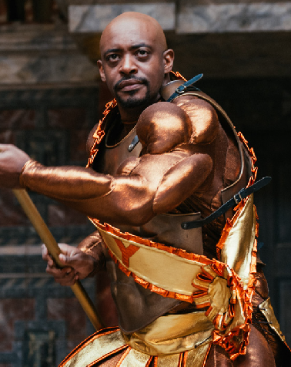
Oliver Alvin-Wilson Hector / Calchas

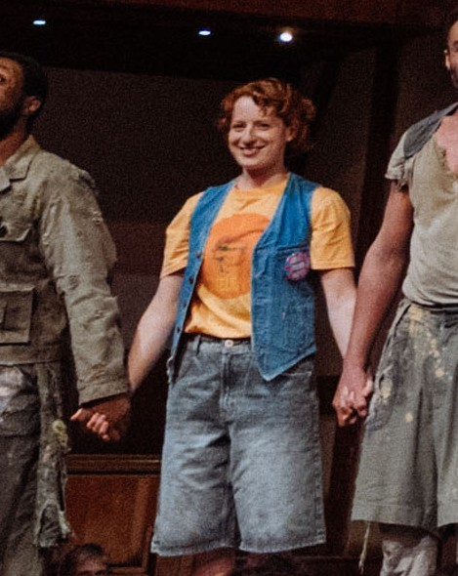
Tilly Botsford Ensemble / Cover


David Caves Achilles

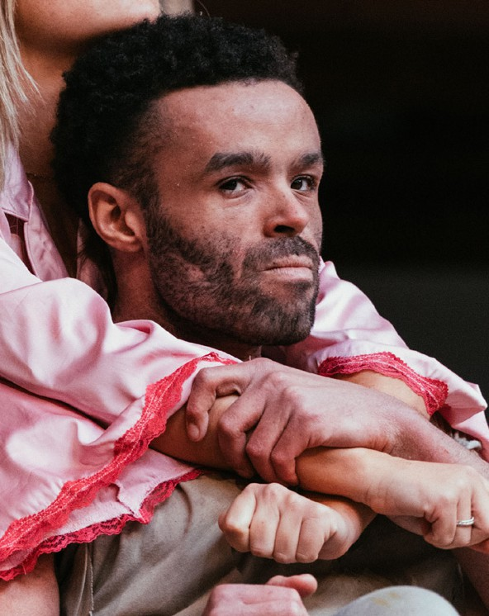
Conor Glean Diomedes / Antenor


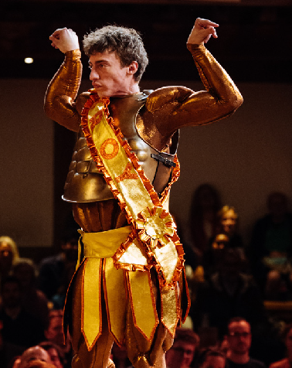
Kasper Hilton-Hille Troilus


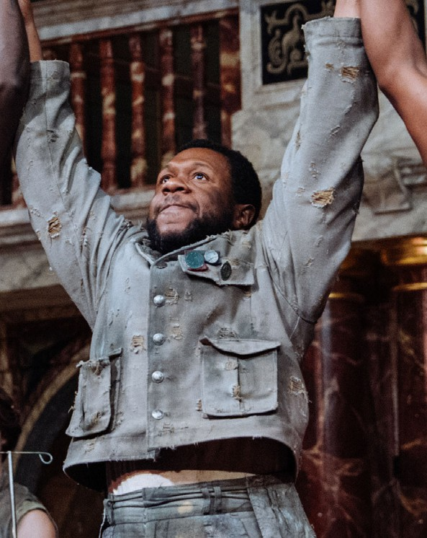
Jonathan Livingstone Agamemnon

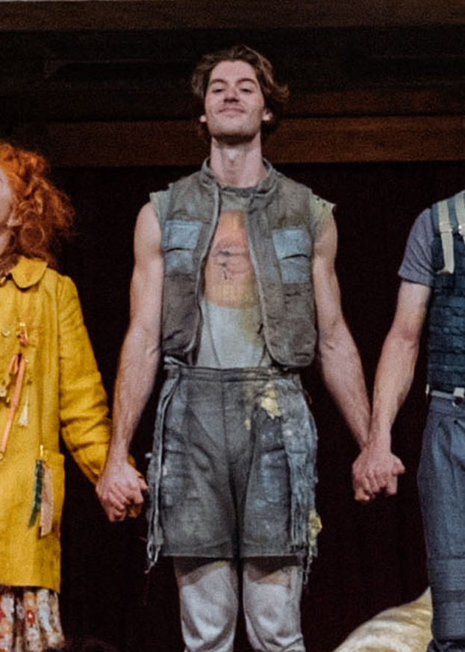
Tadeo Martinez Patroclus / Alexander



Lucy McCormick Thersites / Helen


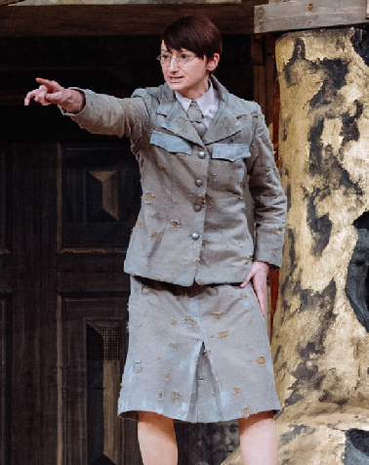
Jodie McNee Ulysses / Cassandra

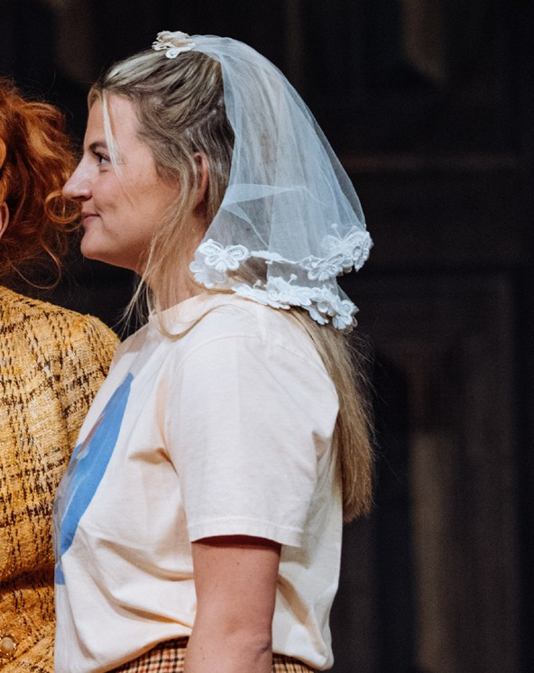
Charlotte O’Leary Cressida



Finn O’Riordain Ensemble / Cover

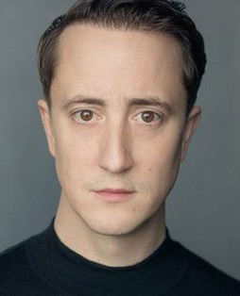
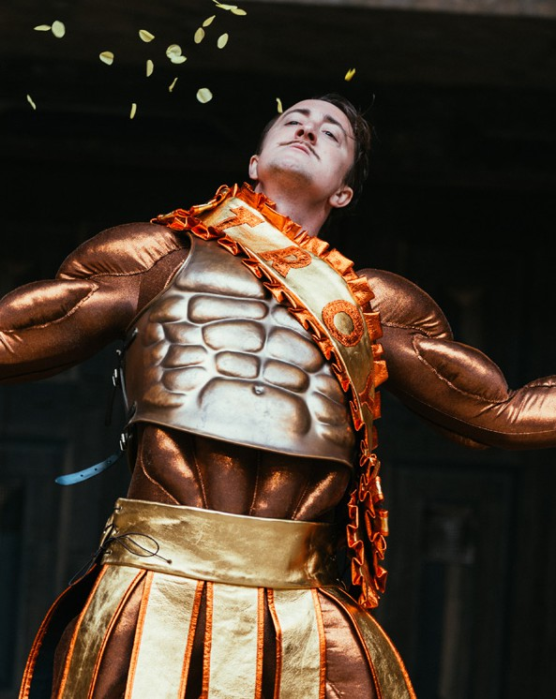
Matthew Spencer Paris / Menelaus

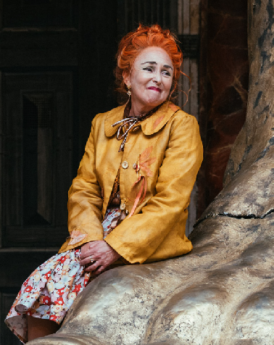
Samantha Spiro Pandarus / Nestor

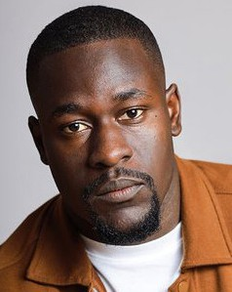
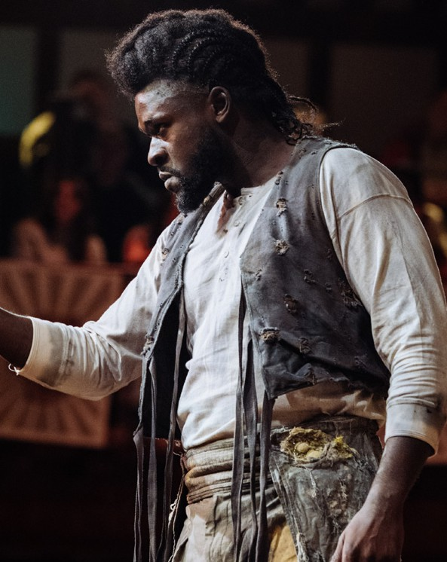
Ibraheem Toure Ajax

Show Notes

Relaxed Performance
A relaxed performance will take place on:

Sunday 19 October at 6.30pm and
Wednesday 22 October at 2.00pm

This will mean:

- An open-door policy: you can come and go as much as you want or need to.


- A culture of acceptance and respect for however you want to experience the show.
- Movement and noise are welcome should you need or want to.
- Pre-show information packs are available online and at the welcome desk.
- A Quiet Space in the Upper Foyer.

The content of the show is exactly the same.

Show Notes

Times
The show is 2 hours and 45 minutes long.

This includes a 20 minute interval.

Music and Sound
The sonic story gives details on the music and sound throughout the show.
You are welcome to wear your own audio
mufflers or borrow some from us.

Lighting

Shakespeare’s Globe Theatre is an open-air theatre. During the daytime the theatre
is lit by daylight. At night the stage will be illuminated so you can see the performers clearly.

The lighting therefore remains the same throughout the whole show.

Set and props
You can see many of the costumes used throughout the performance in the pictures throughout the synopsis.

The set looks like this:

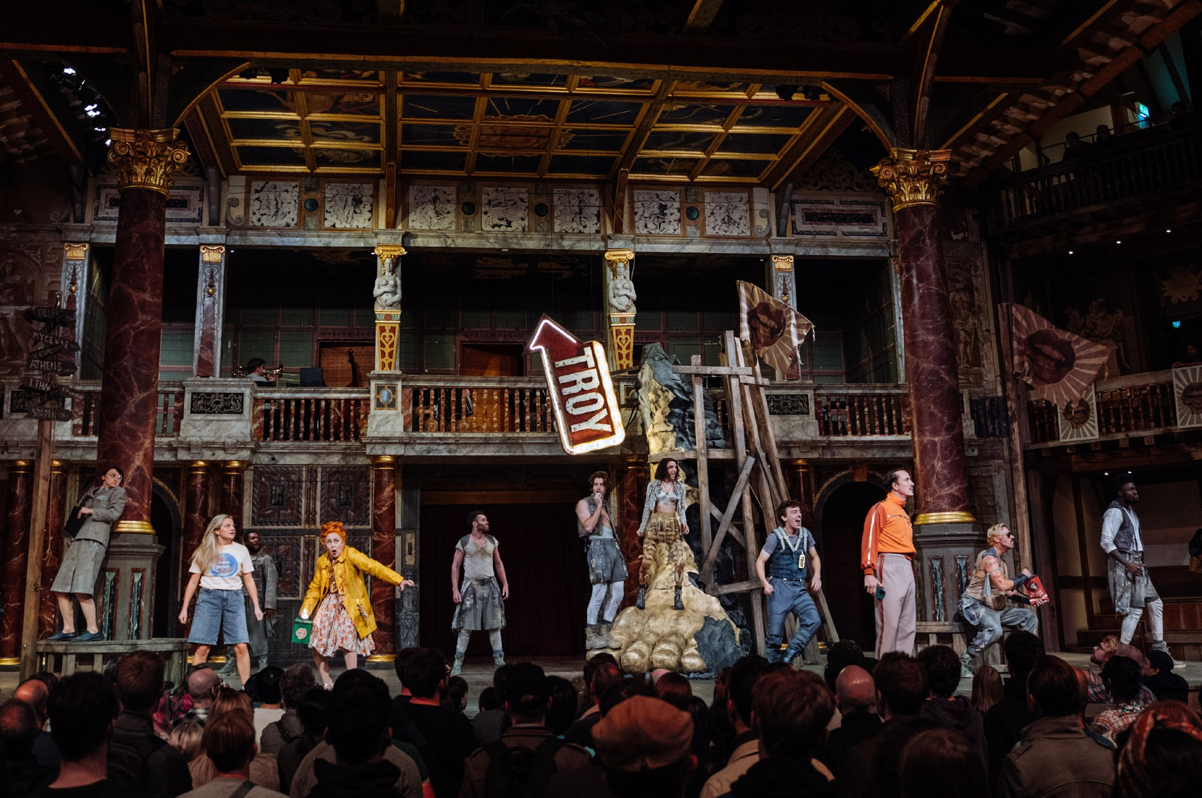

Many of the characters wield prop weapons during the play, but they are safe and nobody gets hurt by them.

If you don’t want to know the plot of the show, you can skip to page 18.

Troilus and Cressida - Synopsis

The play starts with the trap door slamming open. Thersites climbs out of it, and explains that Greece and Troy are in the middle of a war, which is where the play starts. The war started because the two different armies were fighting over Helen. Helen is currently living in Troy with Paris, because he won her from the Greeks.

Lots of people enter, cheering and dancing to music. Troilus shouts “peace!”, and everyone leaves apart from Troilus and Pandarus.
Pandarus helps Troilus to take his armour off, and they talk about Cressida, who Troilus is in love with. Pandarus has been helping the two of them get together, but she says she won’t help Troilus anymore. She leaves. Troilus complains about the war, and about Pandarus not helping him. A soldier enters briefly, then they both exit.
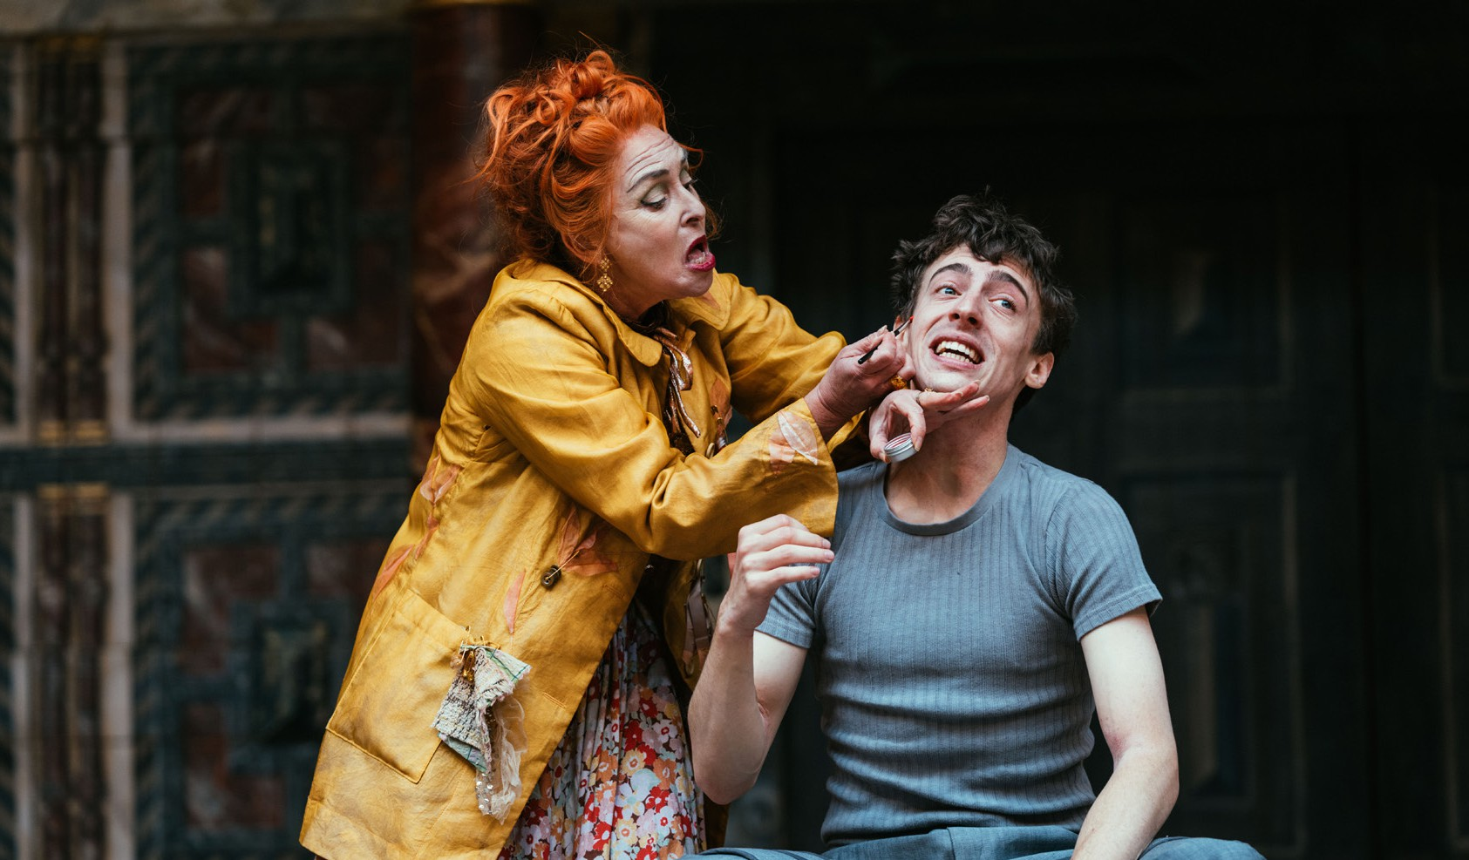

Cressida and Alexander enter. Alexander says that Paris is back in Troy and has been injured. He also says that Hector, who is usually calm, is angry because his cousin Ajax hurt him in battle. Pandarus enters, and argues with Cressida about whether Hector or Troilus is a better man.

Troilus and Cressida - Synopsis

The men of Troy arrive - including Hector, Troilus and Paris. Pandarus introduces them one at a time as they march on dramatically.
Cressida talks about one of the Greek soldiers, Achilles, and how he’s better than Troilus. Then Alexander tells Pandarus that Troilus wants to see her, and they leave together. Cressida speaks about how she doesn’t want to show Troilus that she loves him, and then leaves.

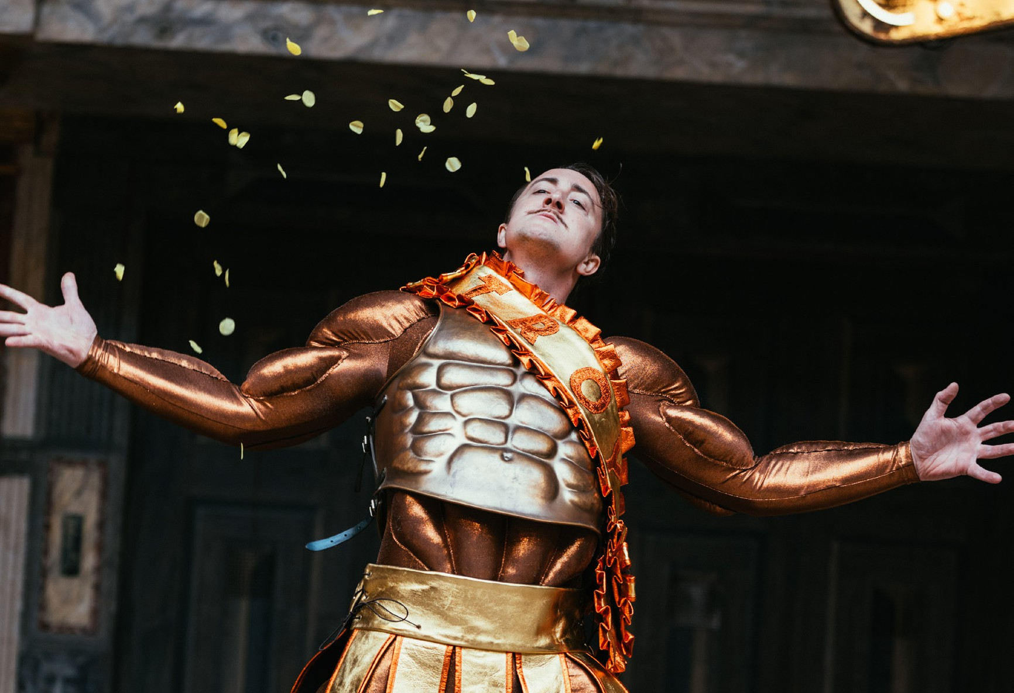

Agamemnon, Ulysses, Menelaus, Diomedes and Nestor enter. Agamemnon said they shouldn’t be disappointed in their efforts. Ulysses disagrees and says that the soldiers don’t respect the people in charge enough, and this is why they’re doing badly in the war. They talk about Achilles and Ajax. Nestor and Ulysses think that they are over-confident, which has made them lazy and rude.
A soldier enters with a letter, which says Hector is ready to fight a Greek soldier half-way between Greece and Troy. Ulysses says that Hector probably wants to fight Achilles, but they should send Ajax instead, and pretend he’s their best soldier. This will encourage Achilles to try harder, which will motivate the rest of the army.

Troilus and Cressida - Synopsis

Ajax and Thersites enter. Thersites has the proclamation, and Ajax asks her to read it. She refuses, and Achilles enters with Patroclus. Achilles reads the letter to Ajax. Everyone leaves, including Ajax, who goes to learn more about who will fight Hector.
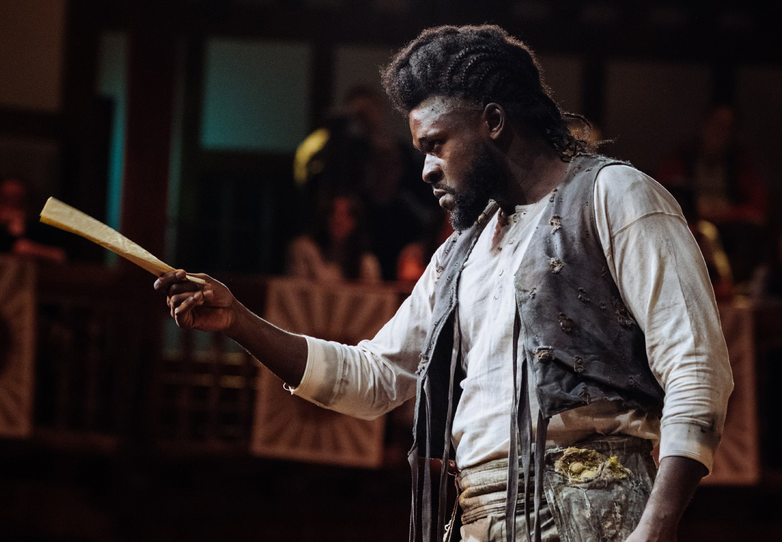

Hector, Troilus and Paris enter. They talk about Agamemnon’s offer
- if they return Helen to the Greeks, they will forget about the war. Hector and Troilus argue about what to do. Then Cassandra enters, shouting”cry, Trojans, cry!” into a megaphone. She thinks that Troy will fall, and that it will be Paris’ fault. She is dragged away. They continue discussing what to do with Helen, and eventually agree to keep her in Troy. They all leave.
Thersites enters and talks about Ajax and Achilles. Patroclus enters, and Thersites starts to chant at him before asking where Achilles is. Achilles enters, and Thersites says he, Patroclus and Agamemnon are all fools. Achilles goes to his tent with Thersites.
Agamemnon, Ulysses, Menelaus, Diomedes and Ajax all enter, and ask where Achilles is. Achilles won’t talk to them and refuses to fight. Agamemnon tells Ajax to go and talk to Achilles, but Ulysses says it isn’t worth it because Achilles is too arrogant. They all leave.

Troilus and Cressida - Synopsis

Pandarus enters with Alexander. Alexander makes a dramatic announcement: Helen of Troy has arrived. She walks on with Paris. They all talk about Troilus and Cressida, then Helen makes Pandarus sing. Pandarus doesn’t sing very well, so Helen sings a song about love instead. Lots of people enter, wearing masks and dancing. The song ends, and Helen falls to the ground crying. Everyone leaves.
Troilus enters, followed by Pandarus. Pandarus says that Cressida is getting ready and will come soon. Cressida enters, looking nervous, and tries to leave. Pandarus convinces her to stay, and Troilus
and Cressida confess their love to each other. Cressida feels a bit embarrassed, but Troilus comforts her. Everyone leaves - Troilus and Cressida go to their bedroom.
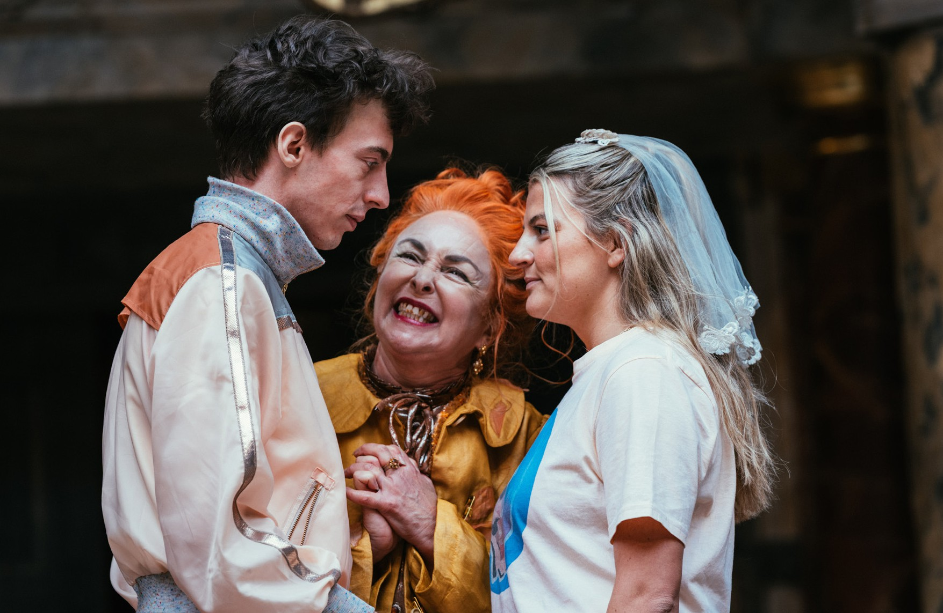
Agamemnon, Ulysses, Diomedes, Ajax, Menelaus and Calchas enter. Calchas says that if the Greeks return a soldier, Antenor, the Trojans will give them Cressida. Agamemnon agrees and everyone leaves.

Troilus and Cressida - Synopsis

Thersites enters along with Troilus and Cressida. It’s early, so Troilus tells Cressida to go back to bed. Pandarus enters and teases them.
Someone knocks at the door. Pandarus answers it and Troilus and Cressida leave. Paris enters, looking for Troilus. Troilus re-enters. Paris tells him that they must give Cressida to the Greeks. The two of them leave, and Cressida re-enters. Pandarus explains what Paris said, and Cressida says she won’t leave. Troilus and Paris return and Troilus says Cressida must leave. He says he will visit her by bribing the guards. Troilus gives Cressida his sleeve. Then Diomedes enters and takes Cressida away. Everyone leaves.
The Greeks enter. The stage is set ready for the fight. Agamemnon and Ulysses agree to treat Achilles like he’s unimportant. Achilles notices this and worries about his reputation. He talks to Ulysses about how his reputation is changing, and about Ajax’s upcoming fight. A trumpet sounds, and everyone leaves.
Thersites introduces the fight, then Ajax enters with the Greeks. Cressida is brought on, and all of the Greeks kiss her - apart from Ulysses, who Cressida pushes away. Ajax and Hector fight in a boxing ring. Hector stops the fight and says Ajax is his cousin. They hug.
Achilles says he will fight Hector instead of Ajax, but for now, they
should be friendly and have dinner and drinks together.
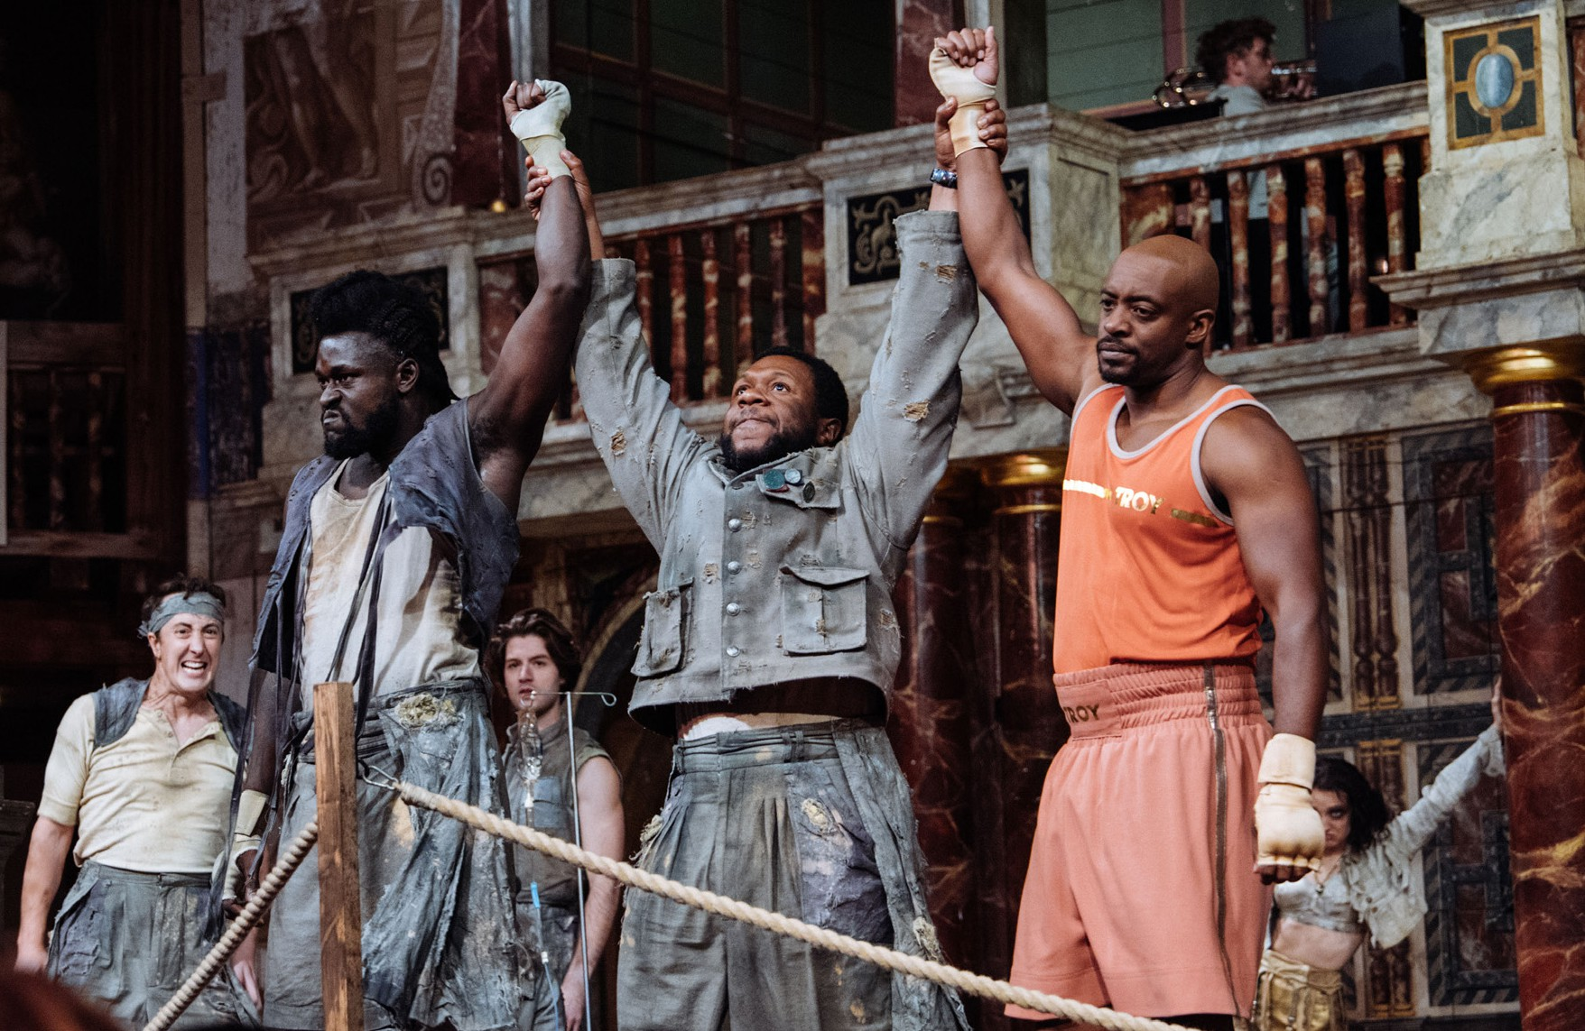

Troilus and Cressida - Synopsis

The Trojans are welcomed into the Greek camp and they all start to party. Thersites joins them, dressed up as Helen. Everyone drinks, dances and laughs together. Thersites makes fun of Nestor and Agamemnon. Thersites and Hector kiss. Achilles asks where Cressida is. The party finishes, and everyone leaves apart from Patroclus and Achilles. Achilles says he won’t fight Hector. Both of them leave.
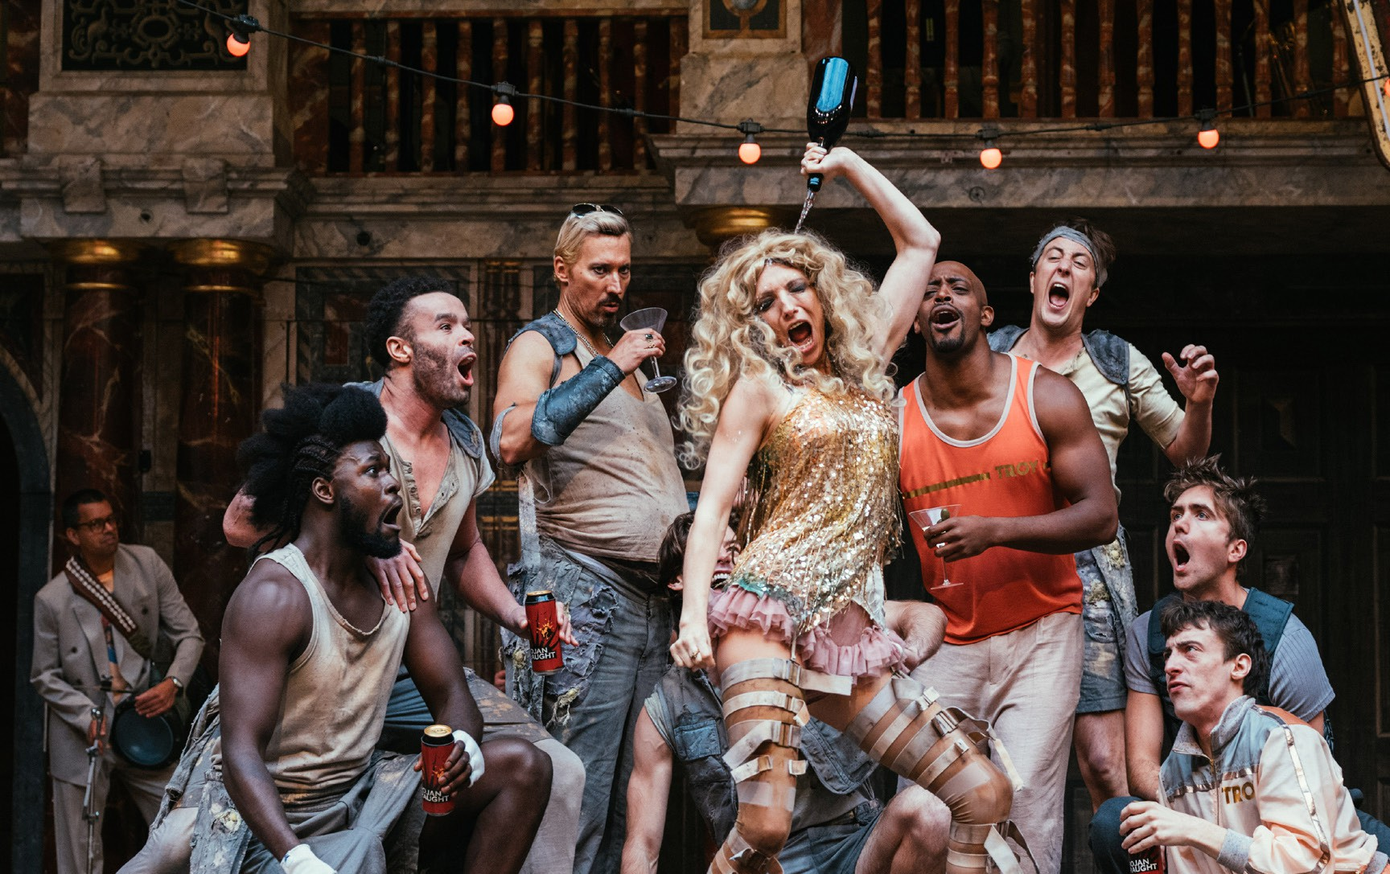

Diomedes enters, and Cressida is pushed on stage. Ulysses and Troilus watch as they talk. Diomedes wants to have sex with Cressida, but she’s not ready. She gives Diomedes Troilus’ sleeve, to show she’s committed to having sex with Diomedes in the future. She regrets giving him the sleeve, and takes it back. This annoys Diomedes.
Troilus is very jealous and upset. Everyone leaves.
Troilus puts on some armour, then Hector enters and says he doesn’t want Troilus to fight. Troilus disagrees. Cassandra enters and tells Hector not to fight because she’s predicted he’ll lose and die. Hector ignores her. Cassandra says this will be the downfall of Troy, and leaves. Pandarus enters with a letter from Cressida. Troilus reads it then tears it up. They all leave.

Troilus and Cressida - Synopsis

Thersites enters and explains that people are about to fight. Diomedes and Troilus enter and begin fighting, and so do Paris and Menelaus. Patroclus and Ulysses enter, and Ulysses kills Patroclus. Achilles runs on stage, demanding to know where Hector is so he can fight him. Ajax and Diomedes go looking for Troilus. They find him and begin fighting. Then Hector enters and begins fighting Achilles.
Achilles stops the fight as he is not strong enough. He leaves.
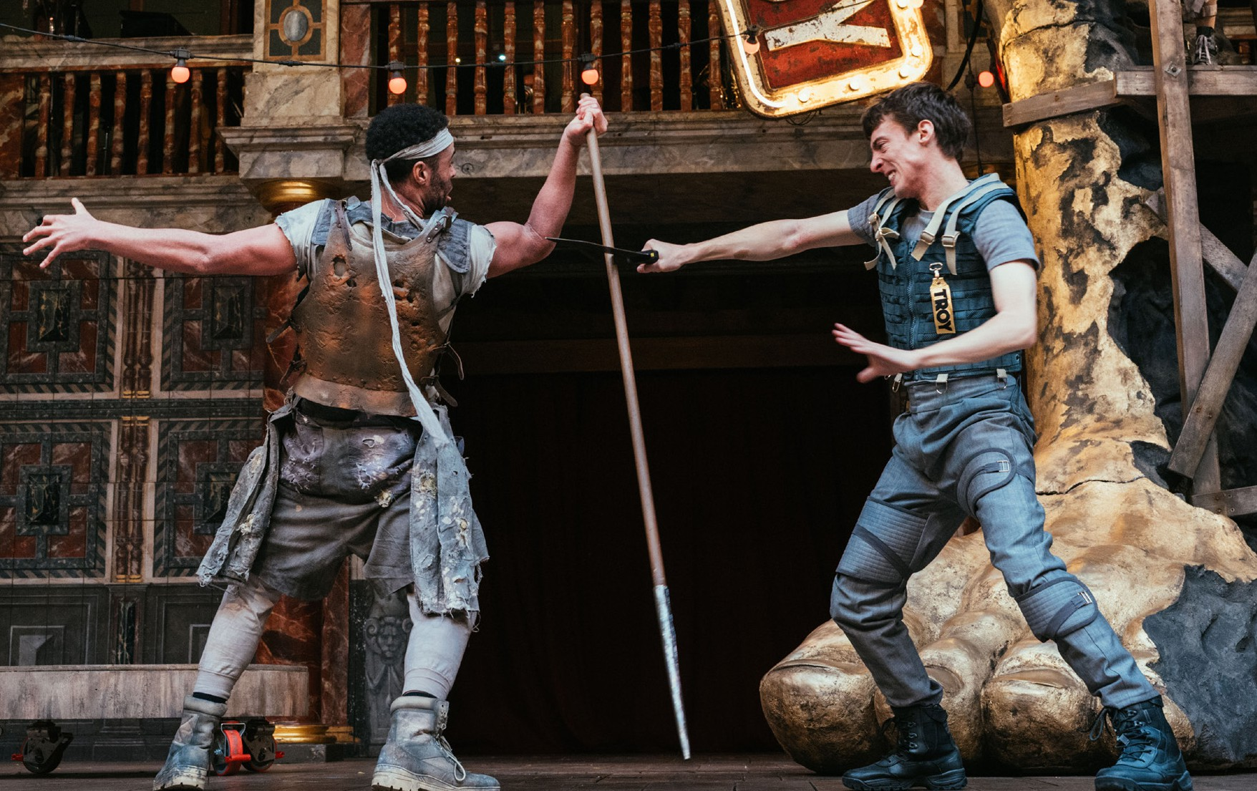
A soldier walks on and Hector chases after him. Achilles sneaks behind Hector and kills him. Achilles tells his army to take Hector’s body away. The Greeks come on stage and learn that Hector has died. They think this means that they’ve won the war, and that Troy is theirs.
The Greeks leave, and Paris and Troilus enter. Troilus tells Paris that Hector is dead, then Pandarus enters. Troilus shouts angrily at her then leaves. Pandarus sings the same love song Helen sung earlier. Pandarus makes a sad speech about how she has been treated. The play finishes, and the cast come on to dance, cheer and clap.

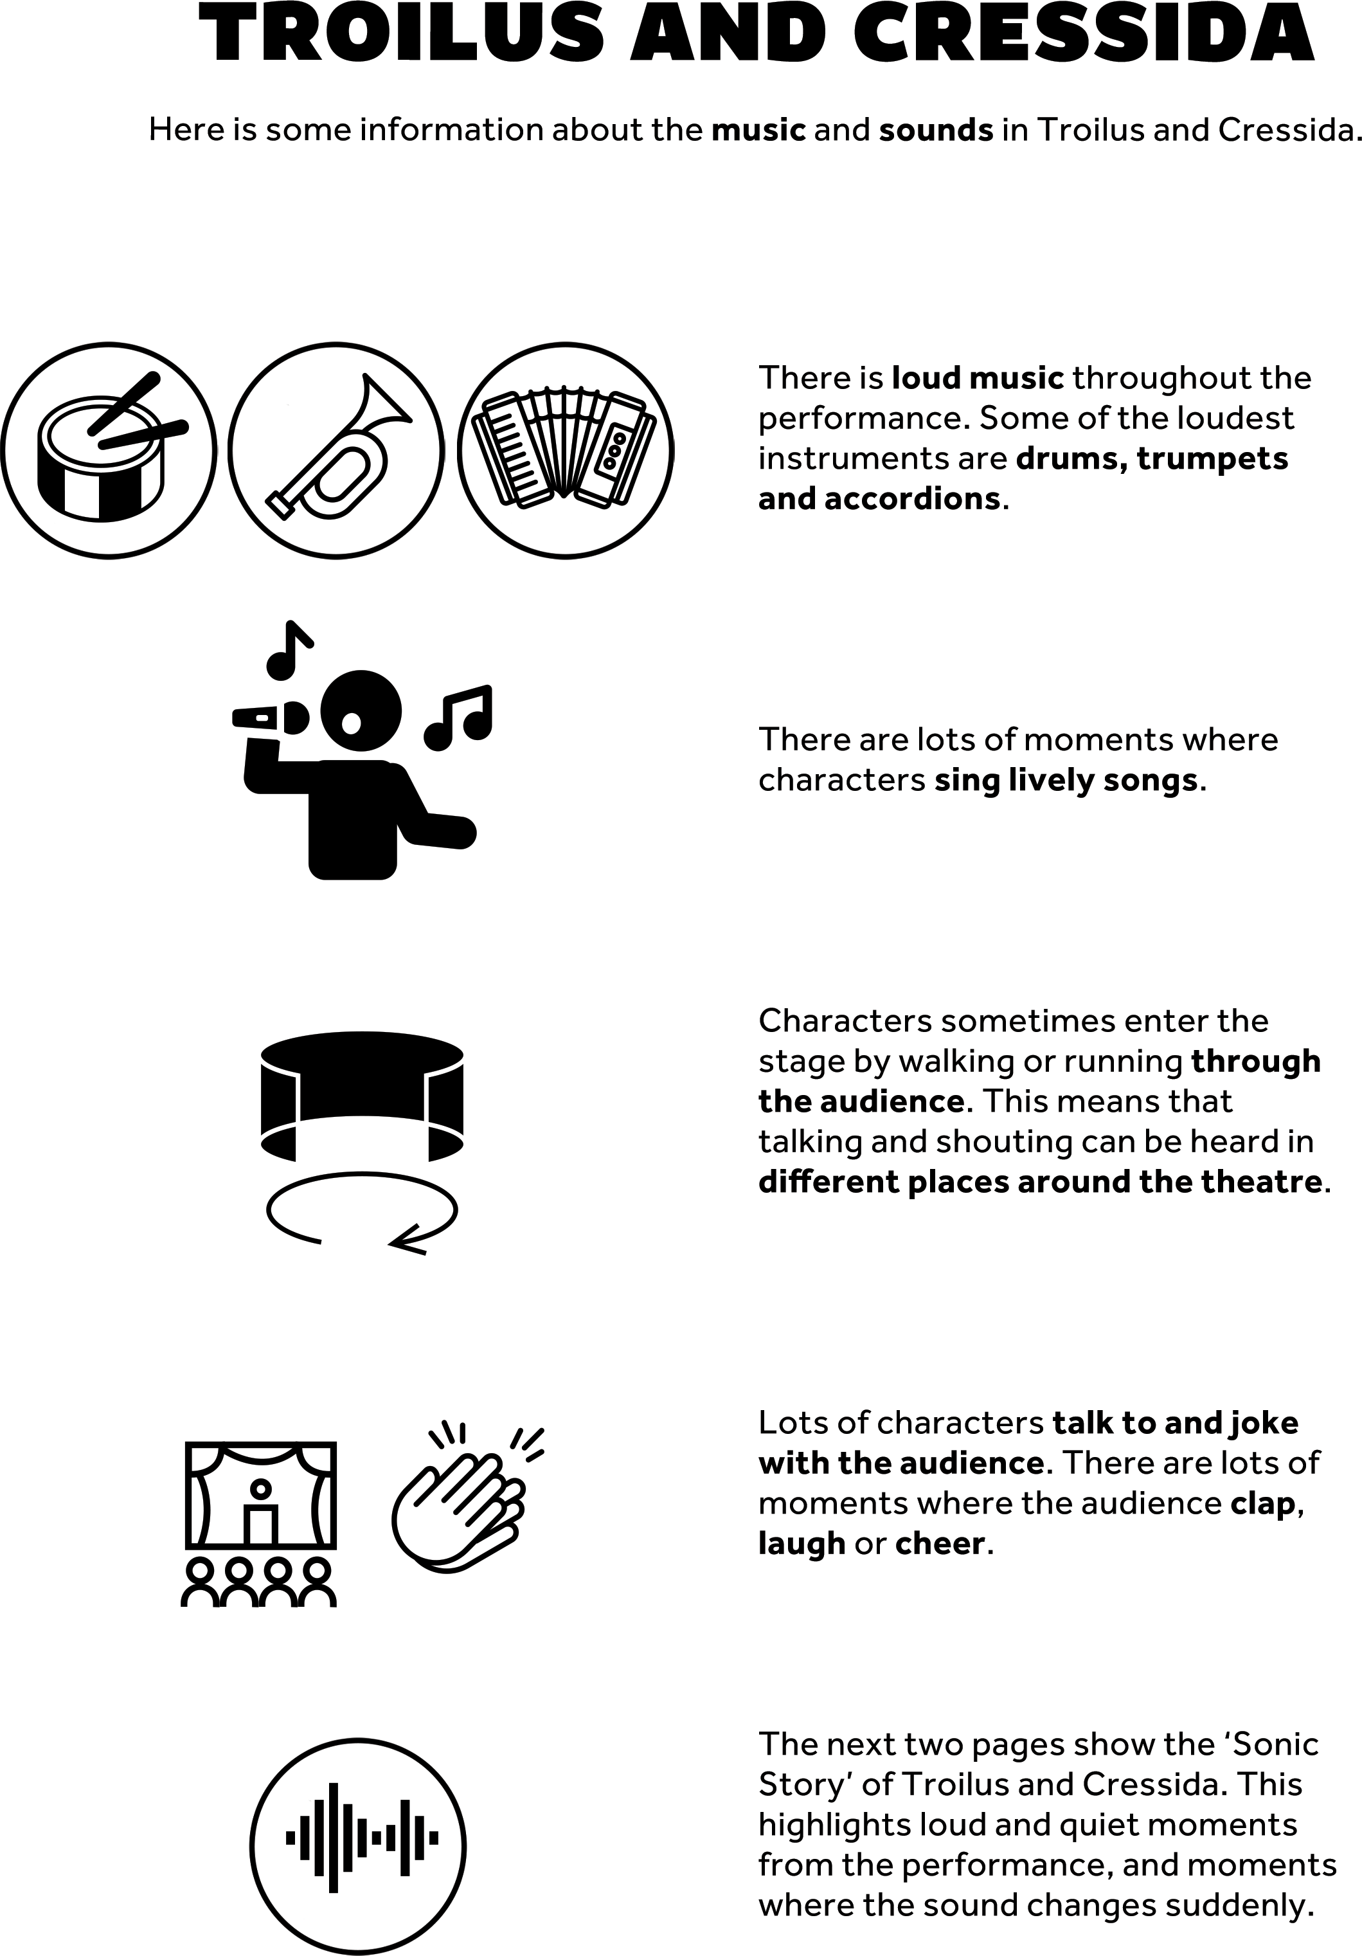

Sonic story provided by Touretteshero

TROILUS AND CRESSIDA

Act 1 starts with very loud banging of trap doors, brief quiet, and another
Sonic Story Act 1
Characters
shout in unison,

Triangle,
Very loud•
Loud• Quiet•

loud bang. Then cheerful brass music and drums.
then exciting brass music and accordion.
Brief exciting brass.
then brief brass and percussion.

 |  |  | Piano, drums, accordion
 |  |  | followed by
 |  | Drum roll, | eerie music.
Brief burlesque | Cheerful | tense | Loud cymbal
style music, then | brass, then | accordion, | as Act 1 ends
Alexander | eerie | dramatic | and audience
screams "Helen!". | accordion. | brass. | applaud.
) ) ) )
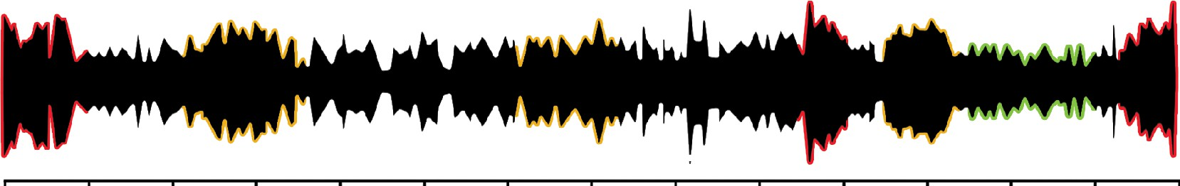
Mins 5 10 15 20 25 30 35 40 45 50 55 60 65 70

Oompah music resumes briefly, slows down and stops.
\-yJ  ( | ( |  | 'y | (
Oompah style | Angry | Everyone on |  | Panderus
brass, rapid | shouting, | stage shouts |  | claps.
drum rolls,  audience clap. | fighting and  stomping. | "Ajax!",  audience
chant and
clap. Drums,
 |  | brief brass.

Cassandra shouts into a megaphone, then cheerful brass music.

Laughing, singing into microphone, accordion, loud scream, crying.

Act2

Act2 starts with Thersites shouting "but soft!".

Distant
shouting.

Cheering and laughing, dramatic music, bell dings, chanting, fighting.
Sad, repeated piano notes, eerie screeching tone, distant shouting.

Ulysses shouts "Troy burns!".

Sad, slow music, distressed shouting.

Laughter, running, distant
knocking.

Fighting,
shouting,
trumpets.

Brief quiet, then growling and cheering.
Chaotic music and people partying.

Loud
arguing.
Tense music becomes upbeat, speaking into microphone, fighting, clapping, singing.

) ) ( ) )


Mins 5 10 15 20 25 30 35 40 45 50 55 60 65 70
I
l
1
Pandarus Eerie accordion, Characters Shouting, Eerie
shouts in drums, audience walk on and off drums, music,
panic. chanting, funny stage while brass and screaming, trumpet solo. singing and accordion. bell tolls,
cheering, shouting,
distant drums.
accordion.

Eerie drum roll, shouting, brass and drums, Cressida screams.
Angry
shouting.
Eerie piano
and accordion.
Two loud bangs of trap door.
Pandarus sings while crying and laughing. Play ends, audience clap and cheer, music plays.

Further information



Contact Details

Should you require more information or wish to discuss your access requirements please contact the Access team on access@shakespearesglobe.com or 020 7401 9919.


We welcome feedback about your Relaxed Performance experience at Shakespeare’s Globe. Please contact us on the above details.

